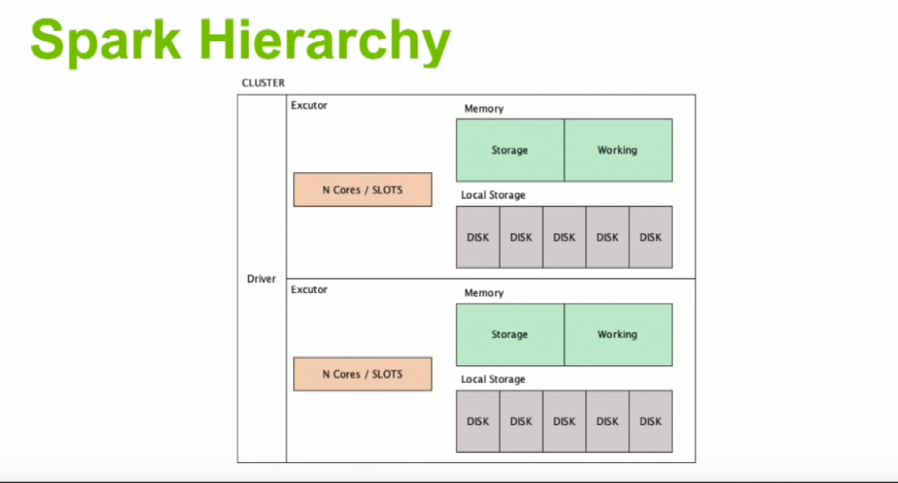

Apache Spark Core—Deep Dive—Proper Optimization Daniel Tomes Databricks

Link : <https://www.youtube.com/watch?v=daXEp4HmS-E>

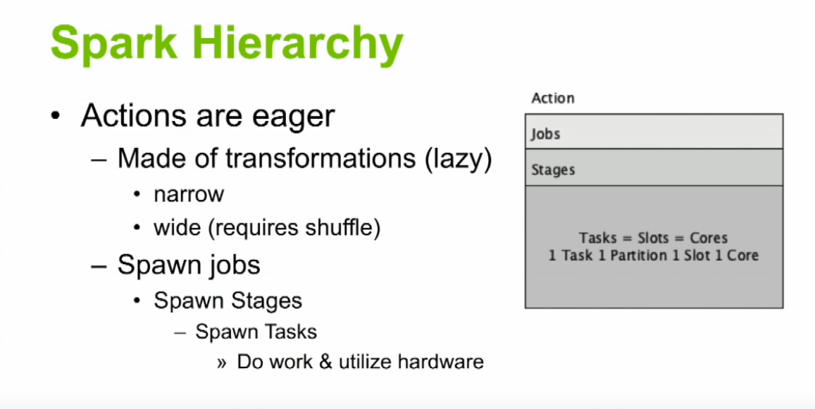

1. 1 Task means 1 Partition and is executed by 1 core. And 1 core takes 1 slot. Slots are nothing but where tasks fit into

